Lab Power Distribution – System Design

Rich Rademacher

University of Waterloo / IQC

March 2018

# Purpose

This document describes the system design of the local Ion Trap Lab DC power supply and distribution for quantum computation.

# Requirements

This system is designed to:

1. Distribute the most common required voltages to various areas around the experiment setup
2. Provide isolated power to as many locations as possible
3. Provide convenient plug-in connectors that minimize mis-wiring
4. Provide a topology that minimizes ground loops
5. Minimize stray noise

# System Design

The system is designed as a hierarchal power distribution chain with local regulation.

## Topology

A series of high-power, low noise power supplies provides all main power trunks, which are distributed throughout the experiment. The final power rails used by the lab equipment is provided from local low-noise linear regulator boards. These boards also provide connectors. The topology is shown below:



Figure Power Distribution

## Power Delivery Requirements

The local regulator box provides the following voltages:

* 2 rails of +5VDC @ 1.5A
* 2 rails of -5VDC @ 1.5A
* 2 rails of +15VDC @ 1.5A
* 2 rails of -15VDC @ 1.5A
* 2 rails of +24VDC @ 1.5A

Additionally, the board provides a means of monitoring voltage and current if needed.

## Local Regulator & Jack Panel Box

The local regulator & jack panel box is the unit that will be placed on the experiment table. This box is connected by Festoon cable to the spiderbox distribution board. It provides last-minute power supply regulation & noise reduction, as well as a connector panel for easy equipment powering.

The jack panel box uses RCA connectors, which are familiar from home audio/video. This connector was chosen for the following reasons:

* RCA connectors have good high-frequency grounding capabilities (100% shield)
* They have sufficient high-current handling (fat center pin and large surface shield)
* They can be color-coded, reducing wiring problems
* They are inexpensive
* They have easy connection to good RF cabling

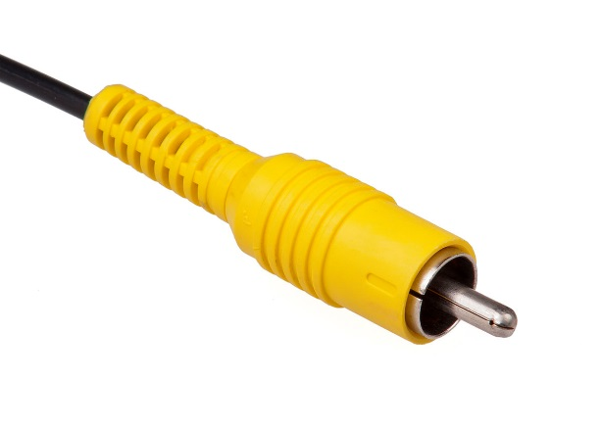

Figure RCA Connector

Each jack panel box provides two independent voltage regulators for each rail. For cost reasons, the jacks are split into “left side” and “right side” jack sets, meaning the +5V outputs on the left are isolated from the +5V on the right, and both are isolated from all other output jacks (i.e. +5V left is isolated from -5V left, -5V right, +15V left, etc).

Each left-side, and right-side can regulate up to 1.5A at its specified output. Left and Right outputs can be paralleled to give up to 3.0A total per box per voltage.

The output voltages are not adjustable. The local regulators are tuned to give lowest noise and highest power supply rejection.

The local regulator & jack panel box also provides an accessory connector for a voltage monitor and alarm circuit, should one be needed.

## Acopian Gold Box Power Supplies

The master power generators are Acopian Gold Box series power supplies. These power supplies directly connect to the wall outlet, and provide the power “trunks” that are distributed to each local regulator & jack panel box via the Festoon cables.

These power supplies are low-noise, linear regulators. The gold box supplies operate 1.5V-2.0V above the end user rails to provide “drop out” voltage for the local regulators. Each gold box provides 20A of current at its specified voltage, allowing 7 local regulator/jack panel boxes to be powered.

The model numbers are as follows:

|  |  |  |  |
| --- | --- | --- | --- |
| **Power Rail** | **Setpoint** | **Model** | **Price** |
| +5V | +7.5VDC | A8H2800 | $575.00 |
| -5V | -7.5VDC | A8H2800 | $575.00 |
| +15V | +17.5VDC | A18H1800 | $575.00 |
| -15V | -17.5VDC | A18H1800 | $575.00 |
| +24V | +26VDC | A28H1400 | $575.00 |

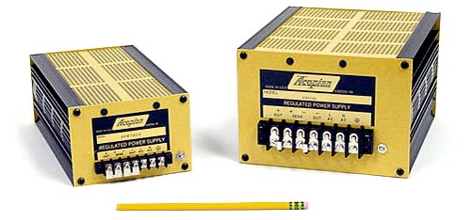

Figure Acopian Gold Box Power Supplies (<http://www.acopian.com>)

## Festoon Cable

The Festoon cable provides the power “trunk” between the spiderbox distribution box and the local regulator & jack panel box. The Festoon cable is supplied to the construction crane industry as a flat, high-current, flexible cord capable of handling current. Additionally, the cable provides the shielding needed for low high-frequency resistance.

|  |  |  |
| --- | --- | --- |
| **Make** | **Model** | **Price** |
| Wireandcableyourway.com | 16/12 shielded flat festoon cable | $6.19 |

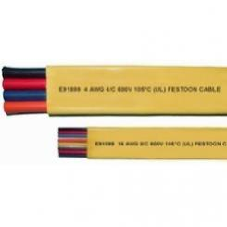

Figure Festoon Cable

|  |  |  |
| --- | --- | --- |
| **Festoon cable pinout** | | |
| **Position** | **Color** | **Purpose** |
| 1 | TBD | +7.5VDC trunk |
| 2 | TBD | Ground |
| 3 | TBD | -7.5VDC trunk |
| 4 | TBD | Ground |
| 5 | TBD | +17.5 VDC trunk |
| 6 | TBD | Ground |
| 7 | TBD | -17.5VDC trunk |
| 8 | TBD | Ground |
| 9 | TBD | +26.5VDC trunk |
| 10 | TBD | Ground |
| 11 | TBD | Ground |
| 12 | TBD | Ground |
| Shield | -- | Ground |

The festoon pinout is shown above. Note that every circuit has its own nearby electrical (DC) ground conductor, and the entire assembly is shielded with a high-frequency (RF) ground.

## Spiderbox Distribution/Splitter

The “spiderbox” is a simple box to combine and distribute the individual gold box supplies to each festoon cable. The box has 5 inputs for each power supply on screw terminals, and 8 output screw terminal sets.

# Technical Background

This section describes technical aspects of good power supply design.

## Ground Loops

Ground loops occur between two devices, which must be connected to a common ground point. The connection path these two devices use is ideally a zero-resistance, infinite bandwidth conductor. In reality the conductors have finite resistance.

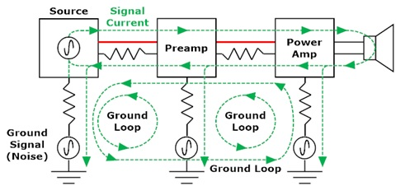

Figure Ground Loops  
 (from http://www.whatsbestforum.com/showthread.php?19891-Ground-Loops-101)

All devices must return the current used to power themselves back to ground. When significant current flows at one ground conductor or the other, and this resistance is high, a voltage is formed. This voltage “lifts” up the device, offsetting any readings it makes. Most equipment is directly powered from 60Hz wall outlets, and so the power current is roughly a 60Hz sine wave. Thus, a ground loop can impose 60Hz onto the signal between a source and its destination. This is the familiar “buzzing” in some audio equipment.

Ground loops are also caused by misunderstanding the frequency characteristics of a ground wire. Simple solid- or stranded-wire has a specified DC resistance, but a sensitive RF circuit will pass current at much higher frequencies. Often wire is a poor conductor at high frequencies, and so it’s a source of this “lifting” noise.

A second way that ground loops manifest themselves is in the signal conductor itself (rather than the ground wire). In this case one device is “lifted” from the other by a fixed amount. The circuit sees the signal wire as a lower-resistance path than its own ground wire, and excess current begins to flow between the devices on this wire. The wire’s resistance converts this to a voltage which is picked up as interference.

A grounding best practice is to use conductors with good high-frequency characteristics. The primary cause of increased high-frequency resistance is due to “skin effect” whereby charges tend to distribute themselves along the conductor surface. Shielded wire increases surface area, but may also sacrifice DC resistance. This is best solved by combining shielding and a solid conductor and connecting both in parallel.

As a general rule, we use cables with wide, flat, ground conductors with high surface area (i.e. shielded wire with separate drain). For large equipment, we use wide copper bus bars in racks and connect with fat shield braid to the power company main ground lug (near a transformer or cold water pipe).

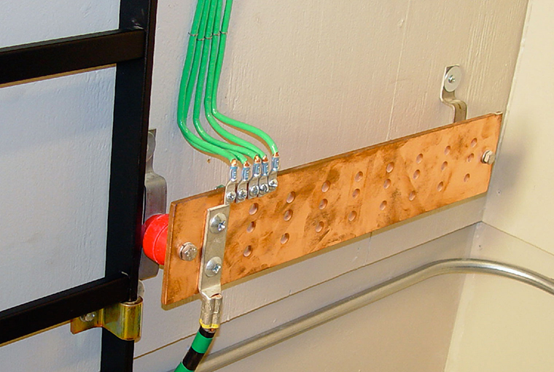

Figure Equipment Bus Bar

## Conducted EMI

Conducted electromagnetic interference (EMI) is one of two main mechanisms that pass noise to an electronic circuit. As mentioned in the section on ground loops, stray signals can also ride on signal wires, causing interference.

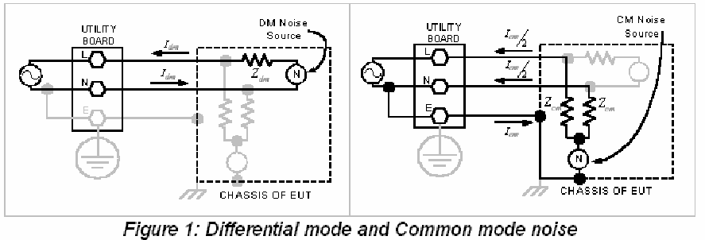

Figure Common Mode & Differential Noise  
(from www.eetimes.com)

For these power supplies, the “signal” is in the power trunks provided from the gold box to the local regulator on the festoon cable. Since the signal is DC power, the voltage regulators allow last-minute isolation from any stray interference that may be on the power trunk. This is specified by the Power Supply Rejection Ratio (PSRR).

The PSRR is measured in decibels and refers to the amount of rejection of input out-of-band noise. Typical regulation bandwidths are below 10 Hz. Thus a regulator with 80 dB PSRR will reduce noise above 10 Hz by a factor of 80 dB.

Linear regulators such as those in the local regulator & jack panel box are effective at removing power-line noise, that may have been picked up from wall sources. They also provide the isolation from the “left side” jacks to the “right side” jacks, as well as those jacks from different voltage outputs. Thus the -5V rail is isolated from the +24V rail by 73-80 dB.

## Radiated EMI

Radiated EMI is the second of the two interference mechanisms. In this case, noise (interference) enters the system by radiation pickup; i.e. the wires that make up a circuit act as pickup antennas *after* a local regulator has removed conducted EMI. A nearby current source creates a magnetic field, and a long stray wire can inductively couple into a sensitive circuit. This is another way the 60 Hz “hum” gets into electronic equipment.

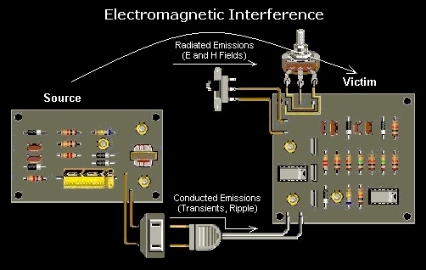

Figure Radiated EMI Pickup (top)  
(from <https://www.wireandcabletips.com/what-is-emi-and-how-can-you-prevent-it>)

Shielding is a best practice for reducing radiated EMI susceptibility. By enclosing the circuit in a Faraday cage, an EM field cannot penetrate. However, two practical factors are key for successful radiated EMI reduction: 100% coverage and high conductivity.

Full coverage refers to the fact that the sensitive circuit must have no electrical gaps in its shield. In practice, this is most common at joints and folds. Corners should be soldered, or use ‘fingered’ tabs to increase surface contact area. Multiple screws should be used to hold down lids to increase the area of contact with good pressure.

High conductivity refers to the limitations of practical materials used to create the Faraday cage. For a perfect conductor, the thickness of the shield can be infinitely thin, since a perfect conductor cannot support a voltage. Practical metals have finite conductivity, and so a “skin depth” determines the amount of attenuation of an EM field as a function of thickness. Since high conductivity metals are too expensive to make the entire box with, best practice is to either coat the interior surface with high conductivity metal (e.g. silver), or to line the inside with a metal inner box (e.g. copper tape). Such linings must be well connected to the system ground.

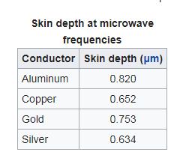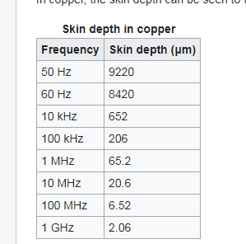

Figure Skin Depth   
(from wikipedia)

For strong magnetic fields high permeability is also important. So-called mu-metals provide the isolation required, however in practice it is best to first attempt to relocate the equipment away from such strong sources.

## Switch-Mode vs. Linear Regulators

There are two main types of voltage regulator designs: linear and switch-mode. Both regulators take in an uncontrolled input voltage and produce a controlled output voltage that is (ideally) constant in time – even when the load changes the amount of current demanded.

Linear regulators control the voltage continuously, adjusting the amount of current through a pass transistor to produce the desired output. In this way they can be modelled as a simple series resistance that adjusts automatically. As it operates, the regulator passes current (needed by the load device), and also drops voltage (the difference between what came in and the desired output voltage). Thus, the regulator itself absorbs power.

Switch mode regulators, on the other hand, do not operate continuously (in the short time scale—they do run a cycle all the time). These regulators turn their transistor fully ON or fully OFF. When fully ON, the full current passes, but no voltage drops since the input and output are the same. When fully OFF, zero current passes, but the full voltage drops across the regulator.

In either case, the power dissipated (as heat) is

$$P=\left(V_{in}-V_{out}\right) I_{delivered}$$

Note that the linear regulator has both voltage drop and current delivered at the same time, thus it is always dissipating power. In contrast the switch mode regulator is either dropping voltage or passing current, but never both at the same time. In theory, the switch mode converter never dissipates power (the transistor’s change from ON to OFF actually does use power).

This design uses linear regulators, and we note the input voltage Vin-Vout has a large effect on power dissipation. For this reason the power trunk lines are run only about 2V above their intended output.

A common parameter to determine how “hot” this device will get is the parameter of “Thermal Resistance”, measured in ºC/W. These vary wildly, but the regulators used in this design are along the lines of 25 ºC/W. Thus each regulator (10 per jack panel box) dissipates 37 ºC above ambient when operating at full power.